
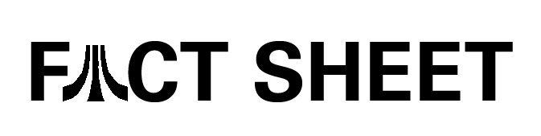
Atari, Inc.
2230 Broadway
Santa Monica, CA 90404
www.atari.com

Terminator®3: The Redemption

Platform: PlayStation®2, Xbox™ and Nintendo GameCube
Release Date: September 2004
Developer: Paradigm Entertainment
Publisher: Atari

Product Description


Terminator 3: The Redemption will take players for a thrill ride into the post-apocalyptic universe as they play the series’ signature icon, Arnold Schwarzenegger. Featuring Arnold Schwarzenegger’s voice and likeness, Terminator 3: The Redemption will surprise players with innovative and exciting gameplay presented in a number of different styles utilizing vehicles and machines straight from the Terminator universe, pitting the Terminator against numerous ground and air-based and enemies.

Terminator 3: The Redemption will feature high intensity arcade style vehicle combat and character based missions from a third-person perspective. The Redemption is presented in a massive and diverse Terminator world, allowing the player to experience gameplay through three distinct timelines. Gamers will see the world of Terminator like never before – they will go places and do things that have only been hinted at in the films, including a futuristic world where Sky Net has defeated the human resistance.

Product Features:
- 14 single player levels in a variety of highly detailed, photorealistic environments.
- Co-op gameplay allowing friends to protect resistance forces on the ground by blasting Skynet opponents from the air.
- Fight as the Terminator in third-person, adrenline rush driving action, which takes place in current day Los Angeles, devastated future Los Angeles as well as alternate future scenarios.
- Engage in classic Terminator combat – rip out opposing Terminator’s power cells and use them as high-powered explosive devices; or use dismantled Endoskeleton torsos as shields, pick-up objects in the environment and pummel opponents with them; or, simply smash opponents to pieces with metal-bending hand-to-hand moves.
- Command any vehicle on the battlefield. Leap from vehicle to vehicle and seize control of Sky Net or Tech Com weapons of war.
- Experience “Terminator Moments,” which reward the player with cool “only Terminator” action shots for executing risky moves or finding short-cuts.
- Utilize vehicle weapons for enhanced Terminator combat, including Tech Com truck-mounted laser cannons and helicopter-mounted chain guns as well as advanced Sky Net weapons attached to Future Killer robots, tanks and hovercraft.
- More than 15 minutes of actual movie footage taken straight from the Hollywood blockbuster Terminator 3: Rise of the Machines.

Contact: Brandon Smith
Atari
310.595.2154
bsmith@atari.com

